GATE TEN EVENTS & PARKING WELCOMES:
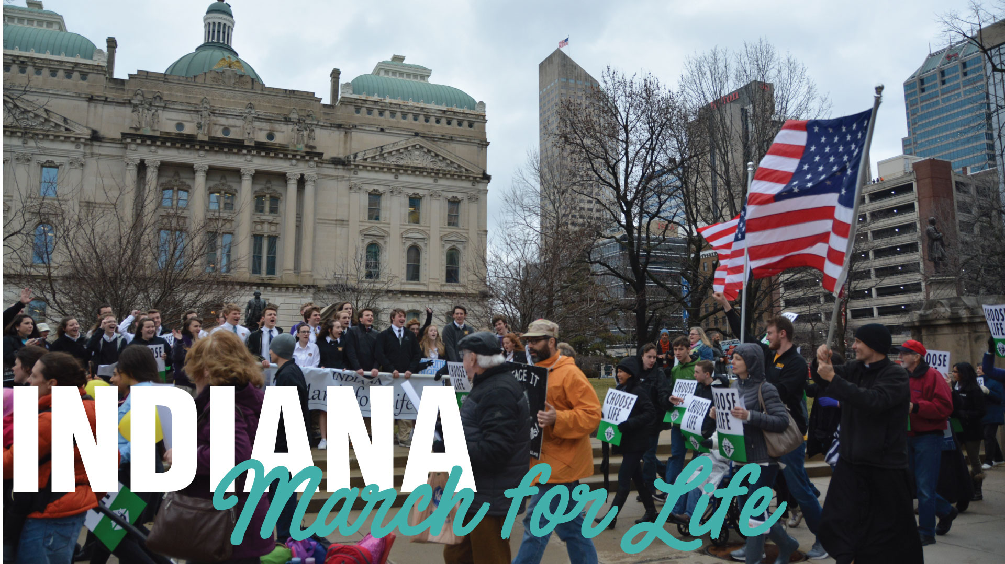
January 22, 2020 – Georgia Street and Capitol Avenue
YouTube Parking Directions https://www.youtube.com/watch?v=JINHeLckhhw

Special Rate Parking
GATE TEN is 100 ft. South of Lucas Oil Stadium. Our prime parking location and events facility is in the “Heart” of the Indianapolis Action. We have space for over 3,000 vehicles and offer a FLAT RATE daily parking fee, with entry and exit privileges and overnight parking is included in daily rate.
FREE SHUTTLE SERVICE! (SHUTTLE TO DOWNTOWN HOTELS AND CONVENTION CENTER)

2020 RATES
Car/truck/Suv $18

15+ Passenger Van Daily Rate $25
Bus Daily Rate …………………………………. $60

To purchase parking passes, click here >> http://www.downtownindyevents.com

What Does Gate Ten Have to Offer?

Our Parking Services:
- Flat one-day rate
- Entry and exit privileges on our lot
- Overnight parking
- Fully lit lot, with onsite watch 24 hours a day, and patrolled by officers to maintain security of lot
- Across the street from Lucas Oil Stadium (300 feet) and about six blocks from Indiana Convention Center
- Our Shuttle Services:
  - Shuttle runs 12-15-minute cycles depending on traffic
  - If staying at a LOCAL downtown hotel we ask that you check in and drop off luggage at your hotel before parking your car with us. This prevents luggage from taking a seat of another person
  - Shuttle service is FREE to ride. Our drivers operate on TIPS only
  - This is an EVENT SHUTTLE ONLY! (Meaning – shuttles will only drop off at the Convention Center or Downtown Hotels)
  - Shuttle will run from downtown hotels, Convention Center, and our parking lot from 6:00 am until 1 hour after the last event of your conference ends at the Convention Center or downtown hotel.

Our Ticketing Service:
- After your parking reservation, you will receive an email confirmation which guarantees you a spot
- When you arrive at the parking facility you will receive a colored parking pass matching the number of days you will be staying

Helpful Links for your travels:

Maps
Downtown Restaurants Map
file:///C:/Users/helpg/Downloads/VisitIndy_DWTNRestMap100119%20(1).pdf

Downtown CVSAddress: 175 N Illinois St, Indianapolis, IN 46204 Phone: (317) 636-6664

