**How to Complete a Life Event Request**

Requests MUST be completed within 30 days of the effective date of your life event

Determine which qualifying event you had or will have with an **effective date within 30 days**

* Change in Legal Marital Status
* Birth, Adoption or Placement for Adoption
* Involuntary Loss of Other Coverage
* Significant Cost Savings
* An Addition or Significant Improvement of a Benefit Package Option
* On account of Orders; such as a qualified medical child support orders (QMCSOs)
* Enrollment into Medicare
* Death

You will need a letter from the previous insurer with the following information before you can begin your life event:

# Names of all covered

* Date coverage terminated
* Type of coverage; must list medical and/or dental

**Follow these steps to complete your life event in Paylocity:**

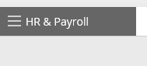

1. Log into your Paylocity account at <https://access.paylocity.com>
2. Click on **HR & Payroll Tab** on the top left of the page, then select **Enterprise Web Benefits:**

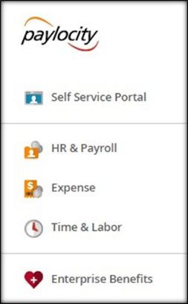

1. Under **Life Events,** choose the appropriate event you are experiencing

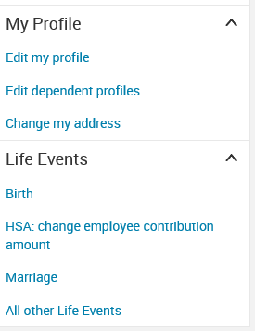

1. Scroll to bottom of Page and select “**Other Life Events,** then select **Employee Loses Other Coverage**

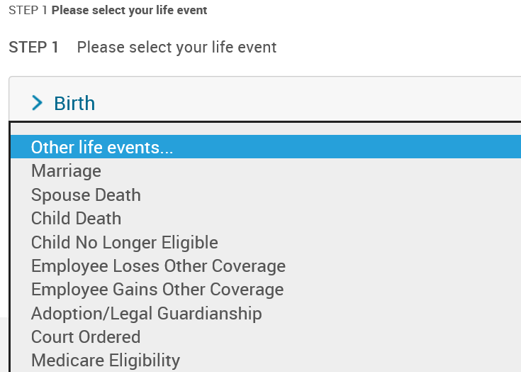

1. Enter the effective date that the coverage terminated

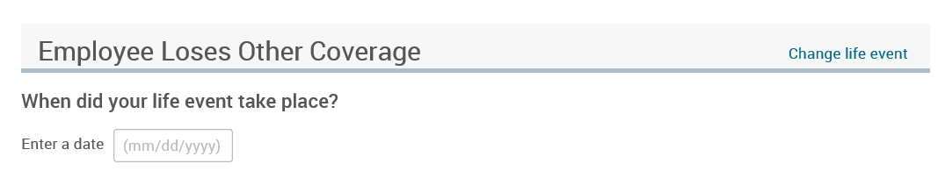

1. Check the box **I agree** and click on **Save and Start Life Event Enrollment**

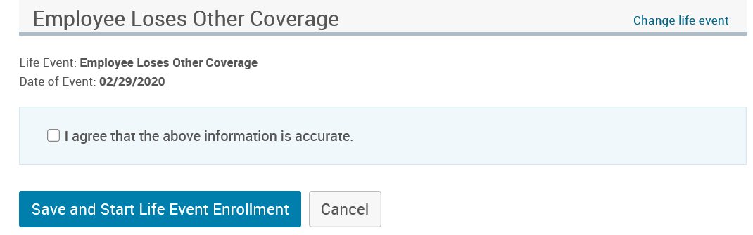

1. Complete the Life Event Enrollment

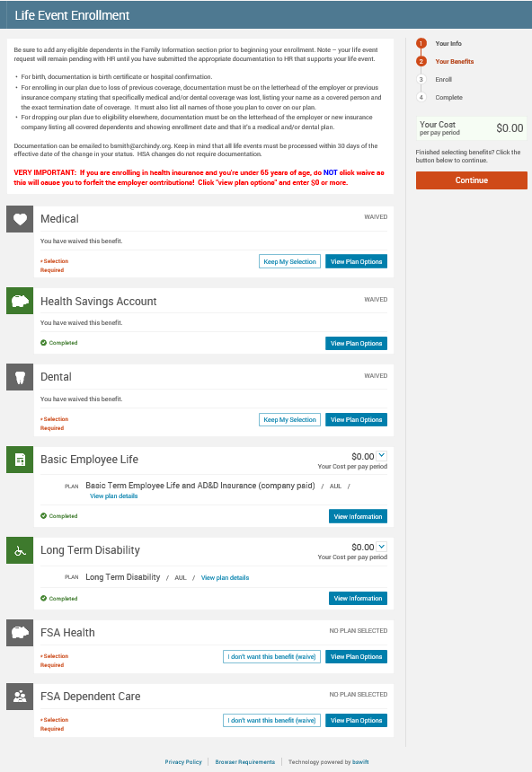

Once you have completed the life event:

1. Upload your documentation by going to **My Profile** and selecting **Employee File**

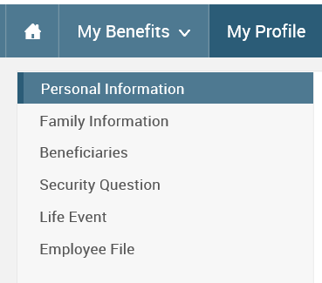

1. Click on **View and Upload Documents**

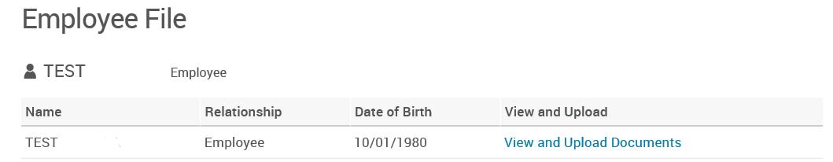

1. Enter the document name and click **Browse** to upload your document. Then click **Save**.

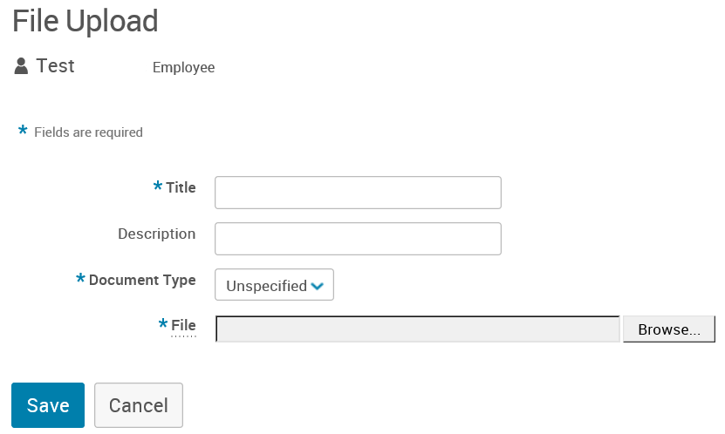

**You may be contacted regarding missed premiums if your life event was a change from the single plan to the family plan or you enrolled in new coverage.**