**How to Change Your Health Savings Account Contribution (HSA)**

**Follow these steps to change your HSA in Paylocity:**



1. Log into your Paylocity account at <https://access.paylocity.com>
2. Click on **HR & Payroll Tab** on the top left of the page, then select **Enterprise Web Benefits:**

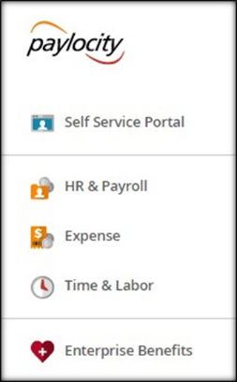

1. Under **Life Events,** choose **HSA: change employee contribution amount**

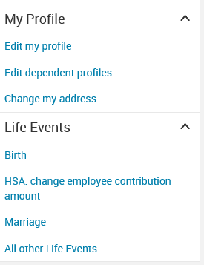

1. Enter today’s date

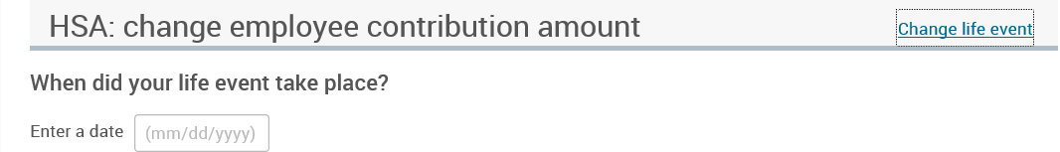

1. Check the box **I agree** and click on **Save and Start Life Event Enrollment**

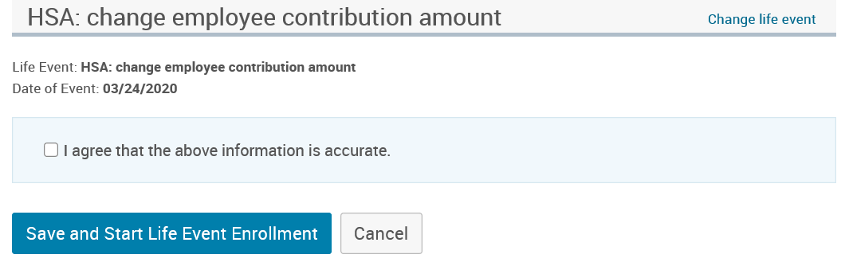

1. Complete the Life Event Enrollment

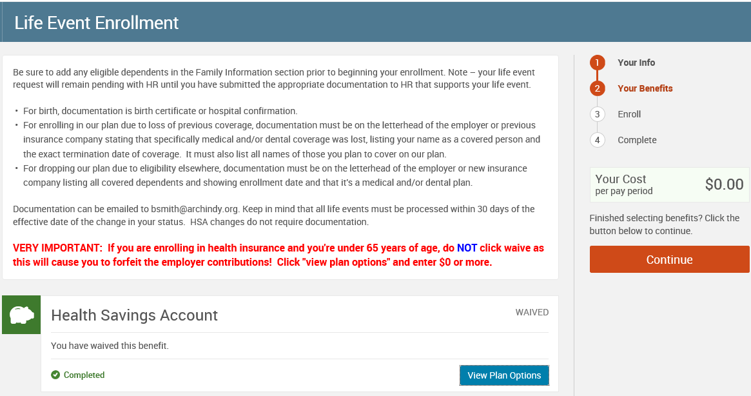

**No documentation is required for changes to your HSA.**