**How to Complete a Life Event Request**

Requests MUST be completed within 30 days of the effective date of your life event

Determine which qualifying event you had or will have with an **effective date within 30 days**

* Change in Legal Marital Status
* **Birth, Adoption or Placement for Adoption**
* Involuntary Loss of Other Coverage
* Significant Cost Savings
* An Addition or Significant Improvement of a Benefit Package Option
* On Account of Orders; such as a qualified medical child support orders (QMCSOs)
* Enrollment into Medicare
* Death

Birth is not a qualifying event to newly enroll in coverage.

You will need one of the following documents to complete your life event:

* Birth Certificate
* Birth Confirmation Letter
* Adoption decree
* Court Order

**Follow these steps to complete your life event in Paylocity:**

1. Log into your Paylocity account at <https://access.paylocity.com>

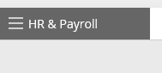

1. Click on **HR & Payroll Tab** on the top left of the page, then select **Enterprise Web Benefits:**

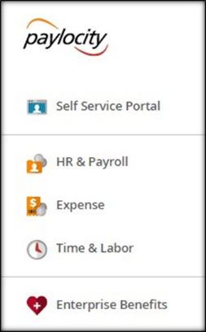

1. Under **Life Events** choose the appropriate event you are experiencing.

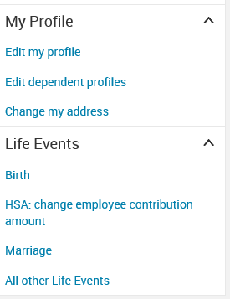

1. Enter baby’s birth date or effective date on the court documents

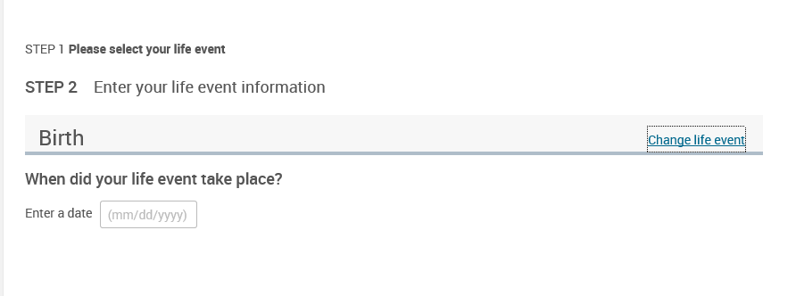

1. Click on **Add Dependent**

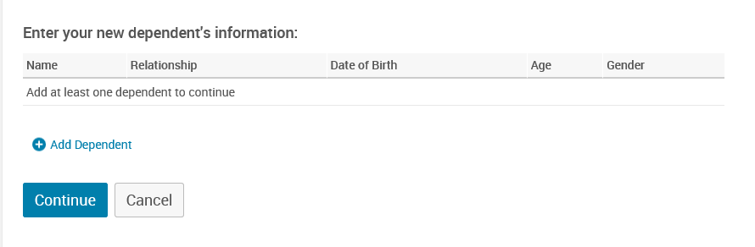

1. Enter all information, then click **Save**. If you do not have the social security number, you will need to add this later.

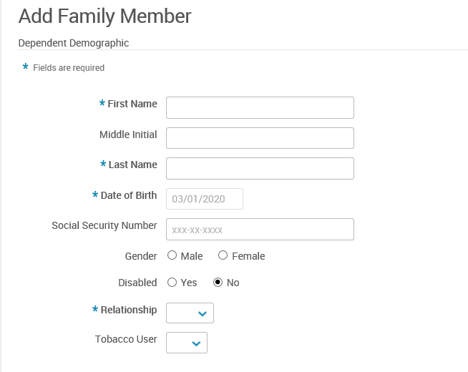



1. Click **Continue**

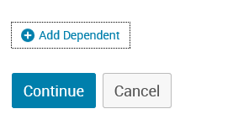

1. Select the **I agree** box and click **Save and Start Life Event Enrollment**

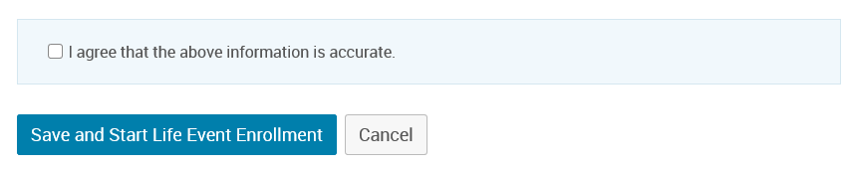

1. Complete the Life Event Enrollment

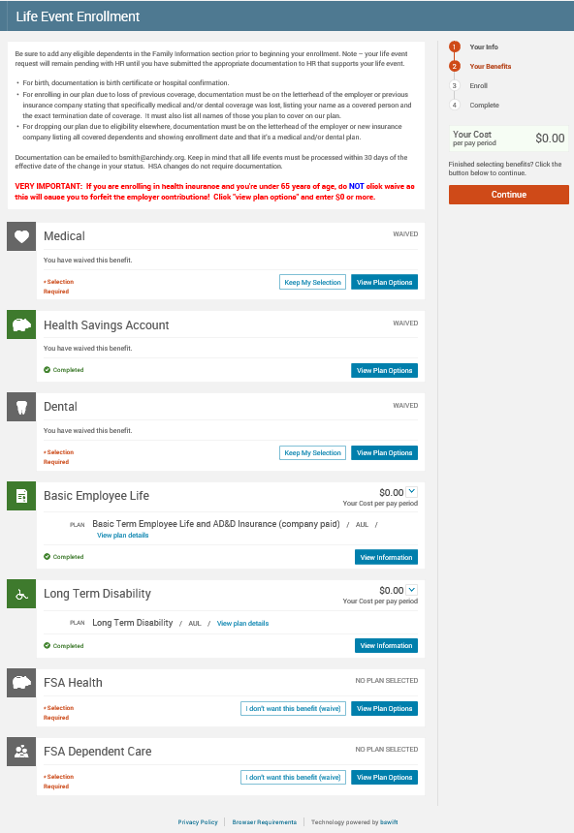

Once you have completed the life event:

1. Upload your documentation by going to **My Profile** and selecting **Employee File**

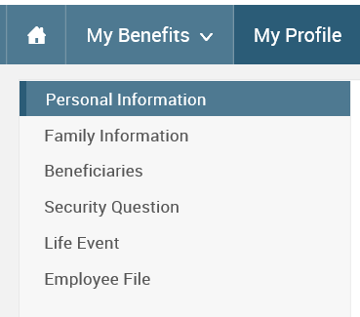

1. Click on **View and Upload Documents** next to your child’s name

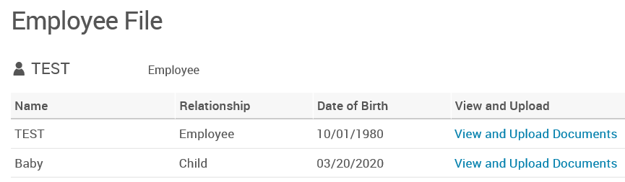

1. Enter the document name and click **Browse** to upload your document. Then click **Save**.

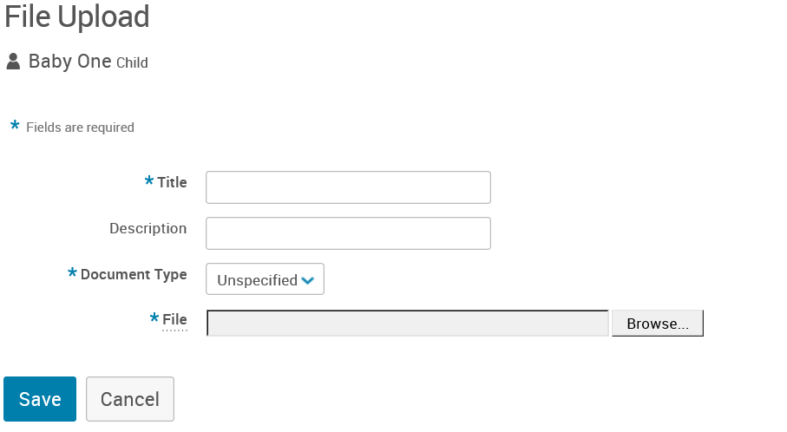

**You may be contacted regarding missed premiums if your life event was a change from the single plan to the family plan.**