Substance Addiction Ministry Mass
Prayer for those struggling with addictions,
their families, and community
August 14, 2018 at 7:00 pm
SS. Peter and Paul Cathedral
1347 North Meridian Street
Indianapolis, IN 46202
Celebrant: Archbishop Charles Thompson

Reception and Refreshments after Mass in SSPP Parlor
For more information, email: mailto:beichhorn@archindy.org
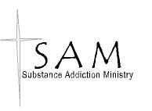
Sponsored by:
Substance Addiction Ministries
of the Archdiocese of Indianapolis

