Sunday, June 14, 2015 ҉ 5 -9 pm
Our Lady of Fatima Retreat House
Visions of Uganda
with
Sherry Meyer
lay missionary of the Archdiocese of Indianapolis
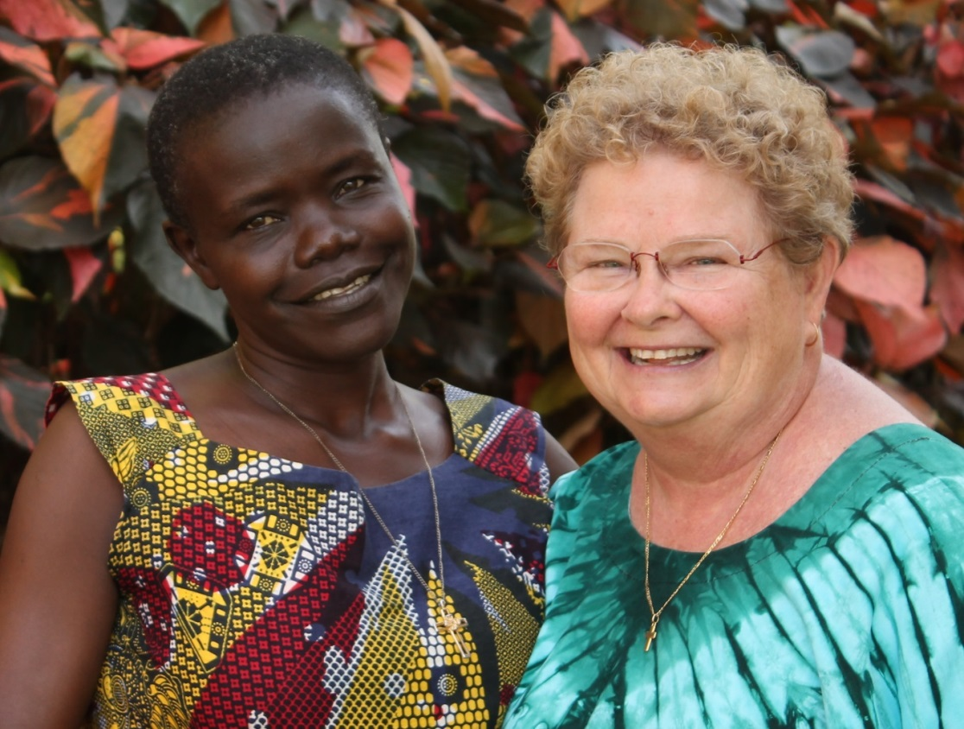

Come join us for an evening of music and stories as Sherry Meyer updates us all on the achievements and goals of her mission work in Uganda. You will hear stories from those who have traveled to Africa to visit and work with Sherry. Enjoy the music of the Tamarindo Band as light refreshments are served. Handmade craft and gift items from the region of Uganda will be available for purchase. You will have the opportunity to offer financial support to Sherry as she continues God's work in this Arua Catholic Diocese.

Limited parking! Share a ride and protect the environment.
For more information call Sherry at (317) 888-5078.

