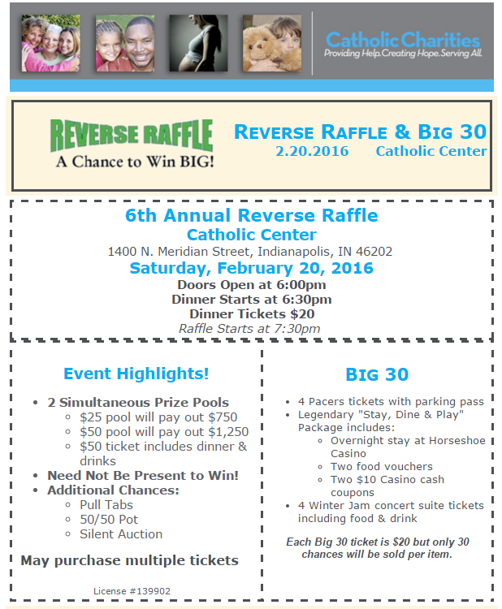

Name ________________________________________________________________________

Address _____________________________________City, Zipcode ______________________

Phone Number ________________________ Email: __________________________________
Please indicate quantity of each below:
_____ $20 Dinner Ticket _____ $25 ticket _____ $50 ticket
_____ Big-30 Item Name (Please indicate which raffle you want to enter): _______________________

Check Check Number ________________

Yes, I will be attending the event. My guest’s name is:_______________________________

No, I am unable to attend but still want to be included in the raffle.

Please return this form to the attention of Valerie Sperka, Catholic Charities Indianapolis,
1400 N Meridian St., Indianapolis, IN 46202

